


Castle Bromwich Infant and Nursery School

SEND Information Report

2025– 2026

Reviewed by:
SENDCo, Headteachers and LAB – June 2025

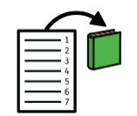

Contents Page
What are our school values? – Page 3
How do we define SEND? – Page 3
Who can I talk to about SEND? – Page 4
How to we identify SEND? – Page 4
Our Identification of Need flowchart – Page 6
How do we adapt teaching for those with SEND? – Page 7-9
How do we keep parents involved? – Page 9
How are children involved? – Page 10
How is information recorded? – Page 10
How do we evaluate our provision? – Page 11
How is equipment resourced? – Page 11
What training do our staff receive? – Page 12-13
What outside agencies do we work with? – Page 13
How do we support transition? – Page 14
What about clubs and trips for children with SEND? – Page 15
What is our complaints procedure? – Page 15
Where can you find support within Solihull? – Page15

  Our School | Our School Vision  Castle Bromwich Infant and Nursery School is a fully inclusive school that is totally committed to providing the best possible education to all of its children regardless of their gender, ethnicity, social background, religion, sexual identity, physical ability or educational needs. This document is intended to give you information regarding the many ways in which we ensure we support all of our children, including those with SEND. It is important to note that it may not include every skill, resource and technique that we employ as these are continually being developed and modified to meet the changing requirements of individual children.
  Special  Educational Needs | At our school we use the definition for SEN and for disability from the SEND Code of Practice (2014).  We support children with a variety of differing special educational needs and we pride ourselves on being a highly inclusive school with an ethos which encourages and celebrates diversity and difference.  SEND is categorised into the following areas in the SEN Code of Practice 2014:
 |  |  | Cognition and Learning
 |  |  | Communication and Interaction
 |  |  | Social, Emotional and Mental Health
 |  |  | Sensory and Physical

  Who can I talk to about SEND? | The Class Teacher  Your child’s class teacher is always your first point of contact for any concerns you may have. They know your child best and can manage your query or pass it onto the relevant staff if needed.  Teaching Assistants/LSAs (Learning Support Assistants)  Teaching Assistants/LSAs across the school support learning in a number of ways. They may work with your child’s class in general or work with groups of children from your child’s class.  The SENDCo  Miss G Bunting is SENDCo at Castle Bromwich Infant and Nursery School. She has worked within 2 local authorities, holds a degree in Education and SEND and has been a qualified teacher for over 10 years. She holds responsibility for coordinating support for children across the school with SEND. The SENDCo holds responsibility for the implementation of the SEND Policy which can be found on the schools website.  The Inclusion Team  The Inclusion Team includes; Lorraine Dickenson (Family Support Worker), Mrs O’Reilly (Deputy Headteacher), Miss C Norton (DSL), Mr J Stokes (Headteacher/DSL), Mrs J Freeman (Inclusion TA) and Miss G Bunting (SENDCo).  The Headteacher  Mr J Stokes is the Headteacher of Castle Bromwich Infants. He is responsible for overseeing all day-to-day aspects of the school, this includes the support for children with SEND.  Local Advisory Board(LAB) Member with Responsibility for SEND  Ms C Lines is our LAB member who is responsible for liaising with the SENDCo and Headteacher regarding appropriate adaptions and provision for children with SEND within the school.  All of the above can be contacted through the school office on 0121 747 3369
  Identifying and  Assessing Need | At CBINS we work closely as a team and if staff have a concern about a child, they implement Quality First Teaching strategies, monitor for 6-8 weeks to begin the Graduated Approach of ‘Assess, Plan, Do, Review’ and discuss concerns with parents.  After a period of 6 – 8 weeks, if that staff member feels there is little progress made, they will fill in an Inclusion form to the Inclusion Team. The team then decide on the best course of action following this which may include, further in-class strategies, SENDco observations or a decision to add the child to the SEND Register. If a child needs to be placed on the SEND register, parents/carers will be invited in for a meeting, where we will share the targets the child is working on and the support they are receiving.  Some children may require more support than is ordinarily available and we may ask outside agencies to support us in ensuring that we are offering the best support we can.  Staff can access the Solihull Local Offer to help support children’s learning within the classroom.  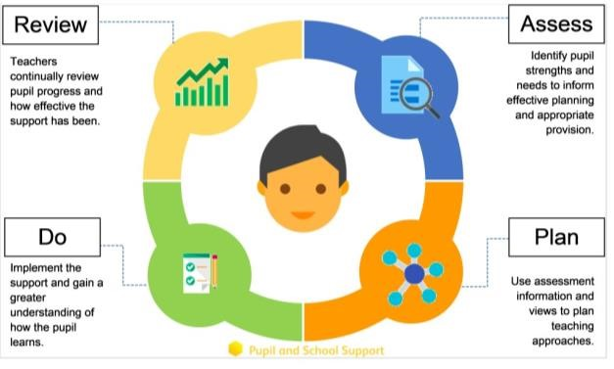
  Identifying and  Assessing Need Flowchart | 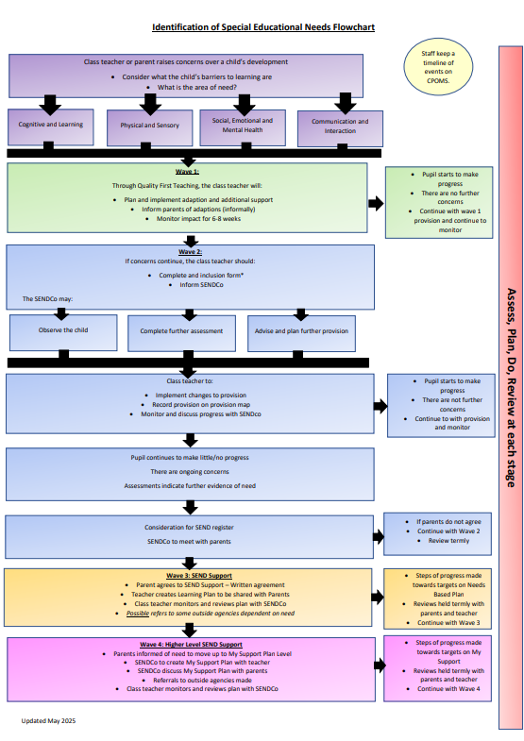

  Our approach to teaching  children with  SEND | We are an inclusive school. Wherever possible children are taught alongside their peers in flexible teaching groups.  Teachers adapt their Quality First Teaching to cater for their pupils’ needs and plan for individuals where necessary. When appropriate, staff are deployed to give children additional interventions.  We offer 3 levels of support in order to accurately meet the needs of children within our school:  Universal – All children access  This includes, but is not limited to:  Quality First Teaching - The teacher holds high expectations for all learners and adapts their teaching methods and support strategies to help them achieve their individual goals.  Targeted support – many children access  This includes, but is not limited to:  Small group/1:1 intervention- the teacher plans and directs the delivery of support to provide extra support for a child’s learning. This may happen at different points during a child’s school life.  Specialist Support – some children access  This includes, but is not limited to:  Outside agencies – intervention is planned/delivered by an external professional from the school to support a specific barrier to learning a child has identified as having.  Specified Individual Support – Children whose additional needs are severe, complex and lifelong  Children who are in receipt of an EHCP receive support based on the needs outlined on their EHCP.  Parents or school can make a request to the Local Authority for an assessment for an EHCP.  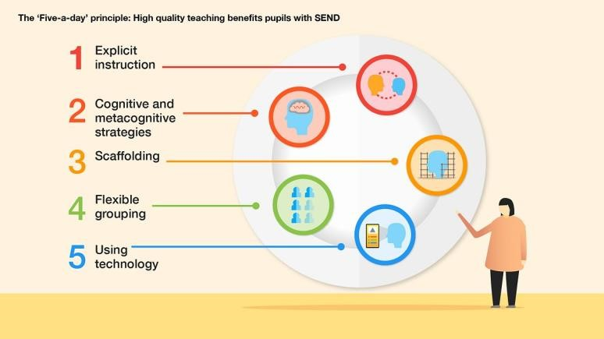  We use the EEF (Education Endowment Foundation) guidance ‘Five-a-day’ and embed the key principles into all our lessons.  We follow the Solihull Local offer produced by the Local Authority to complement our teaching.
  Curriculum adaptations
   |  | 
  Visual timetables | Task boards | Peer mentoring
   |  | 
  Assistive Technology | Talk Partners | Peer Marking

 |  |  |  | 
 |  | Self-assessment | Word banks | Positive behaviour
 |  |  |  | 
 |  | Ear defenders | Timers | Explicit instruction
We use a range of strategies across our lessons to ensure we offer an inclusive approach to learning and allow all children to access the classroom environment.
We also seek advice and equipment from outside agencies as and when the need arises.

  Parent  Consultations | At CBINS we work closely with parents and carers and recognise that they have much to contribute to our support for children with SEND.  For children who have an Education, Health and Care Plan, SEN Support or require specialist support (over and above what is ordinarily available) we will invite parents/carers in for 3 further meetings a year in the Autumn, Spring and Summer terms (additional to Parents Evening). These meeting are used to celebrate your child’s learning, looking at the progress they have made against the targets set, create new targets and discuss next steps. A copy of this will always be sent home after the meetings.

Child  Consultations | Pupil’s views are very important; they have a right to be involved in decisions about their education and they are made aware of the support that surrounds them in school.  Pupils are given regular opportunities to:
   |  | 
  Self-assess how they are doing | Attend meetings and help decide the support needed (where appropriate) | Provide Pupil Voice
  How is information recorded? | When a child is noted as having an additional need, they are added to the school’s SEND register. This notes the child’s broad area of need and additional relevant documents can be formed from this.  Any additional group support or interventions that are put into place are recorded centrally. These are analysed termly by the SENDCo and results fed back to staff and the senior leadership team.  If individual targets need to be put into place, a child with SEND may be given a Learning Plan or a My Support Plan if it is felt they may need an EHCP. This is reviewed termly and shared with parents. Any general updates and reports that are received by school are stored centrally on the CPOMS system and noted on the child’s plan. These can then be shared with senior leaders and key staff members.
  Evaluating  Provision | Progress of pupils is reviewed by SLT and external advisors and next steps are shared with year group staff.  Regular staff meetings are held with a SEND focus to discuss and share ideas to ensure up to date research and policy is in place.  Reviewing children’ individual progress towards their goals at regular intervals, as a minimum every term.  Establishing children’s baseline before receiving interventions and reviewing the impact of interventions at regular intervals.  Children are asked if they feel the adjustment or intervention is helpful and makes a difference.  Monitoring by the SENDCO.  Regularly using a tracking tool to update targets and measure progress.  Holding termly reviews for children who are on Education Health and Care Plans, SEND Support Provision Plans and those requiring specialist support.  Holding annual reviews for children with Education Health Care Plans. Termly
  Resources and Equipment | We regularly assess the needs of our SEND pupils in consultation with parents, teachers, and external specialists.  Based on these assessments, we:  Apply for additional funding through local authority channels such as Top-Up Funding or Education, Health and Care Plans (EHCPs).  Utilise our delegated SEND budget to purchase essential learning aids, assistive technologies, and specialized equipment.  Work with external agencies and healthcare professionals to access expert guidance and resources tailored to individual pupil needs.  We also ensure that facilities such as accessible classrooms, quiet areas, and adapted toilets are available and maintained to support physical, emotional, and sensory needs.  Our approach is dynamic, and we continuously review and adjust support to ensure all SEND pupils are fully included in school life and can achieve their full potential.
  Staff Training | At CBINS, we believe in professional development and aim to ensure all our staff have the understanding they need to enable them to support your child.  When a new member of staff joins the school, we ensure they understand the systems within school and they are given information about the children they are working with.  The senior leadership team within school are constantly moderating needs within the school and, where an area of concern is highlighted, whole school training could be organised to ensure all staff understand specific learning difficulties and appropriate teaching or support strategies that could be utilised.  If your child needs specialist support from an outside agency, such as the  Speech and Language Service (SALT) Paediatrician,  Occupational Therapist (OT) or school nurse, we will always discuss this with parents/carers first.  Some of our staff have completed training in the following areas.
   |  |  | 
  Child  Development | Bucket time | Autism (Level 1) | Makaton – Level
   |  |  | 
  Phonics (catchup) | Team Teach | Specific Learning Difficulties | Speech and Language

 |  |  | 
De escalation | Reading for those who struggle | Sensory needs | Total Communication Training
 |  |  | 
Intensive Interaction | Specific Medical Needs | SMART Target Training | Premature Birth Awareness

  Outside  Agencies | We work with the following agencies to provide support for children with SEND:  - Autism Team  - Speech and Language Therapy  - Sensory and Physical Impairment Team  - Paediatricians  - Occupational Therapists  - SENTAA  - SEMH Team  - Early Years Team  We will ask parent/carers permission before we arrange for any outside agencies to come in and work with a child. Once the feedback has been received we will share the information with you.

  Transition Support | Nursery to Reception  We hold a parent and carer session in the summer term for our new Reception starters, providing parents with the opportunity to meet with the class teacher and SENDCo.  Transition to Reception, and then into each successive year-group, is supported by meetings and information leaflets in each new class.  The SENDCo, Nursery Manager and Early Years Lead attend the annual Transition Event held by the Local Authority to meet with other school and nurseries.  End of Year Transition  When children move up a year, we provide transition sheets which include photos of the teacher, TA and classroom environment.  We hold transition sessions during the summer term allowing the children to go up to their new classroom and meet their teacher.  Some children may require extra transition visits to their new classroom to help reduce their anxiety and ensure that the transition is successful and positive.  Class teachers and TAs meet with each other during the summer term to discuss the needs of the children and share Individual Learning Plans.  Junior Transition  We liaise very closely with our partner school to ensure that the transition from Infant School to the Junior school is as smooth as possible. There is an opportunity for Year 2 children to visit the Junior School as well as their new teachers to visit them at the Infant School.  Mid-Year new starters  When we are aware that pupils joining us from other settings have identified special educational needs, we arrange a meeting with the family to enable us to gain a greater understanding on the support we need to put in place.

  Clubs and Trips | All our extra-curricular activities and school visits are available to all our children, including our before-and after-school clubs (Y1 and Yr2).  All children are encouraged to go on our trips.  All children are encouraged to take part in sports day, school competitions, school assemblies and performances, workshops, etc.  No child is ever excluded from taking part in these activities because of their SEN or disability.  Please read the school’s accessibility plan for further information about the steps we have taken to prevent disabled children from being treated less favourably than other children and the arrangements we have made to help children with SEND access our school.
  Complaint Procedure | Your first point of contact is your child’s class teacher and/or Year Group Lead.  If you are not satisfied that your concern has been addressed, then you may make an appointment to speak to the Deputy Head Teacher. If they cannot solve your issue, then an appointment can be made to speak to the Headteacher.  If you are not happy with the response, then you may contact the Local Advisory board (previously known as the Governors) through the school office.  Ms R Dougan – Chair of LAB  Ms C Lines – SEND Governor
  Solihull  Local Offer | The Solihull Local Authority Local Offer can be found at https://www.solihull.gov.uk/children-and-family-support/localoffer
  EDSEN | 0121 704 6690
  School Nursing Service | 07480 635496
  Solihull Family Hubs | 0121 704 6017
  SENDIAss | 0121 516 5173

