Sparkly Folders

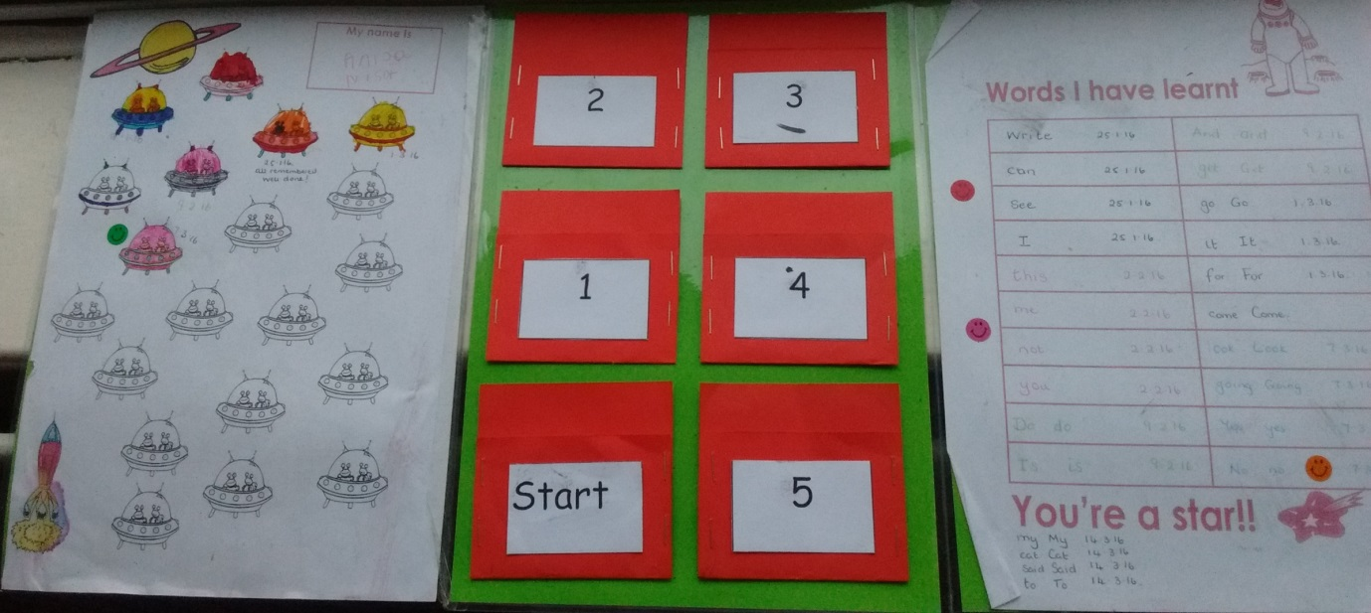
Sparkly folders can be used for daily practice to achieve instant recognition of words (or numbers or graphemes).

This is the inside of the folder which is made of 3 laminated A4 cards sellotaped together.
- The middle section has 6 ‘pockets’. The words are placed in the ‘start’ pocket and taken out by the adult or peer ‘buddy’.
- The child is shown the first card and given a couple of seconds to respond.
- If he/she is not able to read the word on sight the buddy says the word so that the child has the chance to hear the word whilst looking at it. The card is replaced in the start pocket.
- If he/she reads the word on sight it is placed in the next pocket (1).
- Once the child has had the chance to respond to all the cards, the process is repeated, moving the cards round the pockets as the words are recognised immediately and replacing them if the word is read to them.
- In this way the child has plenty of opportunity to hear and see the words that he is unsure of and to gradually put all the words to memory.

The left hand section: this gives a dated record of success. The child colours one of the shapes at the end of the session.

The right hand section: this gives a record of the words learnt. The dates provide good evidence of progress.

