Now / Next Board
What is it?
It is:
- a motivation system
- a type of visual support
It is not:
- a mini schedule / visual timetable
- PECS
- a choice board
Who is it for?
- Children who find it hard to follow adult-led activities
- Children who only choose to participate in a restricted range of activities.
- Children who have difficulty understanding spoken language

Why use it?
A now/next board motivates the child to:
- Learn new skills
- Follow adult direction
- Try activities they would not otherwise choose to do
Begin by introducing the Now/Next Board for a task that your child usually completes willingly and successfully or choose a task that can be completed quickly and then build up to less familiar and more challenging tasks.
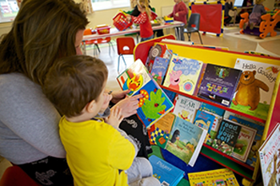

How to use Now/Next:
You need:

- A board (i.e. a laminated piece of card) split into two sections. One section is headed Now and the other Next. In the middle of each section place a square of Velcro.

- Symbols (i.e boardmaker) or photos corresponding to the activities you wish your child to complete (task) and a few of their favourite toys/activities (reward) with velcro on the back.

- Decide what task you want your child to complete now and place the corresponding symbol in the ‘Now’ section.

- Place the symbol corresponding to the motivating reward toy or activity in the ‘Next’ section.

- Present the board to the child with a brief, verbal instruction. For example: “Now, puzzle, Next, cars.”

- When the “Now” task is completed, refer back to the board. For example, say “puzzle finished, next cars!” and immediately provide the reward item or activity.

- In order to teach children the value of the Now/Next Board, you must give them the reward activity or item after they complete the “Now” task. Otherwise, your child may not trust the board the next time you use it.

Consult your child’s Speech and Language Therapist for more guidance and support where necessary.

