Castle Bromwich Infant and Nursery School
Before and After School Provision
2026-2027
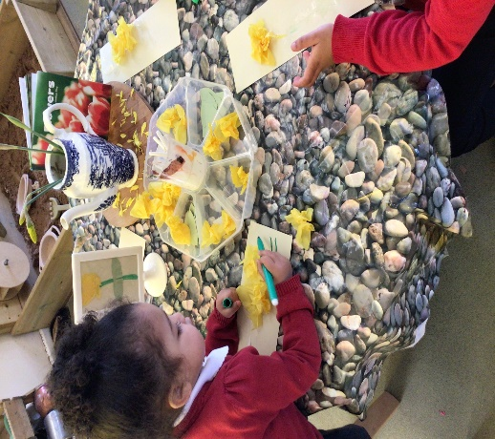
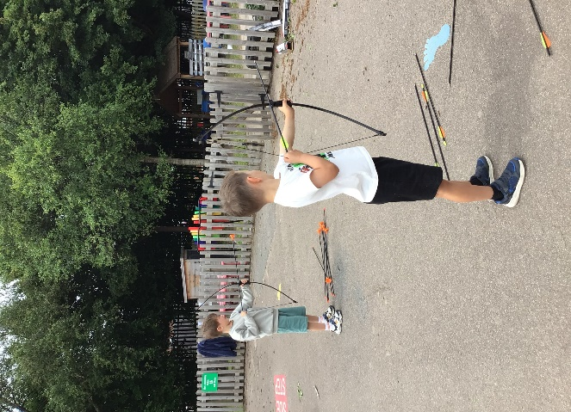

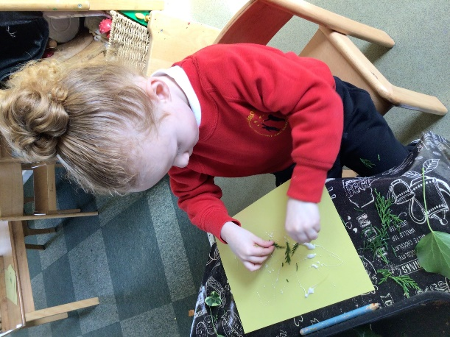
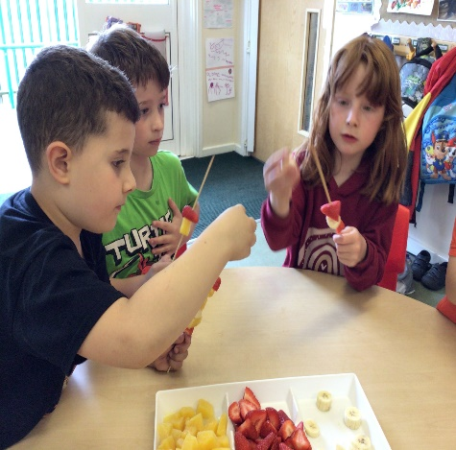


Scan the QR code to book a place

Welcome to Before and After School Provision
Our before and after school provision offers a safe, supportive, and enjoyable environment where children can relax, play, and learn outside of the normal school day. We provide a wide variety of fun activities to suit all interests, including arts and crafts, games, construction, and free flow access to the outdoor area to encourage fresh air and physical activity.
Children are offered a healthy breakfast to start their day and, in the afterschool session, a light tea alongside snacks. All food provided meets dietary needs and promotes healthy eating habits.
Our team of qualified and experienced staff are dedicated to making sure every child feels happy, included, and well cared for. We aim to create a homely, friendly atmosphere where children can enjoy spending time with friends, develop new skills, and have fun before or after the busy school day.
Nursery Prices:
Before School - £7.00
After School until 4.15pm - £8.00
After School until 5.00pm - £11.50
After School until 6.00pm - £14.50
Full Time Place (Every Before School and After School until 6pm) - £100.00
Reception, Year 1 and Year 2 Prices:
Before School - £6.00
After School until 4.15pm - £6.50
After School until 5.00pm - £10.00
After School until 6.00pm - £11.00
Full Time Place (Every Before School and After School until 6pm) - £75.00
*10% Sibling Discount applies for Eldest child
We also offer Holiday Play Schemes during half-term breaks — more information is available upon request.
Scan the QR code to book a place

